## Description: Rajalakshmi Engineering College

## BUS TICKET RESEVATION SYSTEM

**A MINI PROJECT REPORT**

| **Submitted** | **by** |  |
| --- | --- | --- |
| **RAMESH M** |  | **231801134** |
| **SANJAY KISHORE T** |  | **231801152** |
| **SANJAY N** |  | **231801149** |

In partial fulfillment for the award of the degree of

BACHELOR OF TECHNOLOGY

IN

ARTIFICIAL INTLLIGENCE & DATA SCIENCE

RAJALAKSHMI ENGINEERING COLLEGE (AUTONOMOUS) THANDALAM

CHENNAI-602105

2024 - 2025

**BONAFIDE CERTIFICATE**

Certified that this project report **“BUS TICKET RESEVATION SYSTEM”** is the bonafide work of **“RAMESH M(231801134),SANJAY KISHORE T (231801152), SANJAY N(231801149) ”** who carried out the project work under my supervision.

**Submitted for the Practical Examination held on**

**SIGNATURE SIGNATURE**

**Dr.MANORANJINI J Dr.GNANASEKAR J M**

**Professor, Artificial Intelligence and Data Head of the department,Artificial Intelligence**

**science,Rajalakshmi Engineering College and data science,Rajalakshmi Engineering**

**(Autonomous) ,Thandalam,Chennai-602105 College(Autonomous),Thandalam,Chennai-602105**

**INTERNAL EXAMINER EXTERNAL EXAMINER**

**ABSTRACT**

The **"Bus Ticket Reservation System"** is an innovative database management solution designed to meet the demands of modern-day travelers seeking a seamless and efficient ticket booking experience. Unlike conventional booking systems that may involve lengthy processes and third-party involvement, this system allows customers to book bus tickets directly through a dedicated website. By eliminating intermediaries, users can make bookings swiftly and with greater confidence in the transparency of the process. The system ensures that all travel details are accessible at the click of a button, offering real-time seat availability, route information, and travel updates, which empowers users to make informed travel decisions.

One of the standout features of the system is its enhanced processing of booking costs and refunds. Designed to address common pain points in existing systems, this platform offers rapid payment confirmations, minimizing the waiting time for customers. In cases of cancellations or other adjustments, the system is built to handle refund transactions efficiently, ensuring that users receive their refunds without undue delay. This speed and reliability make it an ideal solution for frequent travelers and anyone seeking a streamlined travel experience.

The system is also equipped with advanced features like cancellation management, booking history, and travel notifications, offering a comprehensive platform that meets users' needs before, during, and after travel. It’s designed with a scalable, user-friendly database architecture that allows it to handle large volumes of data while maintaining responsiveness. Ultimately, the "Bus Ticket Reservation System" aims to redefine the traditional bus ticketing experience by providing a solution that is fast, transparent, and equipped with added conveniences that set it apart from standard booking apps.

**TABLE OF CONTENTS**

**S.NO CHAPTER PAGE.NO**

1. **INTRODUCTION**

1.1 INTRODUCTION………………………1

1.2 OBJECTIVES……………………………2

1.3 MODULES………………………………3-5

1. **SURVEY OF TECHNOLOGIES**

2.1 SOFTWARE DESCRIPTION…………6-7

2.2 LANGUAGES………………………….7-8

2.2.1 MongoDB……………………….8-9

2.2.2 NodeJS………………………….9-10

1. **REQUIREMENTS AND ANALYSIS**

3.1 REQUIREMENT SPECIFICATION………..11

3.2 HARDWARE AND SOFTWARE…………..12

REQUIREMENTS

**`**  3.3 ARCHITECTURE DIAGRAM………………13-14

3.4 ER DIAGRAM……………………………….15-16

3.5 NORMALIZATION………………………….16-18

**4. PROGRAM** ………………………………………19-24

**5. RESULTS AND DISCUSSION**………………….25-27

**6. CONCLUSION**……………………………………28

**7. REFERENCES**……………………………………29-30

### **INTRODUCTION**

### 1.1 Introduction

The **"Bus Ticket Reservation System"** is a comprehensive and streamlined platform designed to transform the bus ticketing experience for travelers and operators alike. In an era where digital convenience is paramount, this system provides an efficient, user-friendly, and secure method for booking bus tickets directly through a dedicated website. Unlike traditional booking platforms,this system bypasses intermediaries, allowing for direct engagement with the service, leading to enhanced transparency and faster transaction processing. Built as a database-managed solution, it enables users to explore routes, check seat availability, manage bookings, and receive quick refunds in case of cancellations. By focusing on the user experience and integrating advanced features, this system offers a significant upgrade over conventional booking methods and application

**1.2 Objectives**

The primary objectives of the "Bus Ticket Reservation System" are as follows:

**1.Provide Direct Booking Access**  
Facilitate bus ticket reservations directly on the platform's website, eliminating the need for third-party services and offering users a direct link to travel providers.

**2.Enhance Transaction Efficiency**  
Streamline the payment and refund process to ensure that booking confirmations and refunds are processed quickly and efficiently, reducing waiting times for users.

****3.Deliver Real-Time Availability and Updates****Enable real-time access to route information, seat availability, and booking statuses to allow users to make informed choices instantly.

**4.Optimize User Experience**  
Design an intuitive interface with features like booking history, travel updates, and easy cancellation management to provide users with a convenient and enjoyable experience.

**5.Ensure Data Security and Reliability**  
Implement a robust database architecture to maintain data security, scalability, and consistency, accommodating high volumes of user data without compromising performance.

**6.Reduce Dependency on Intermediaries**  
Provide a platform that directly connects consumers to the booking service, reducing dependency on intermediaries and improving transparency.

**1.3MODULES**

### ****1.3.1 Dashboard (Opening Page)****

The dashboard serves as the main landing page, welcoming users and providing essential navigation. Key elements to include:

* ***Header with Navigation****:* Includes links to essential pages like Login, Signup, Search, and Contact Us.
* ***Search Box****:* Allows users to search for available buses by entering details like source, destination, date of travel, and number of passengers.
* ***Featured Routes/Offers****:* Showcase popular routes, discounts, or promotions for user engagement.
* ***Upcoming Bookings Section****:* For logged-in users, display an overview of any upcoming bookings, cancellations, or trip history.
* ***Real-time Alerts****:* Inform users about any delays, route changes, or weather conditions that may affect travel.
* ***Footer****:* Contains links to customer service, terms and conditions, privacy policy, and social media handles.

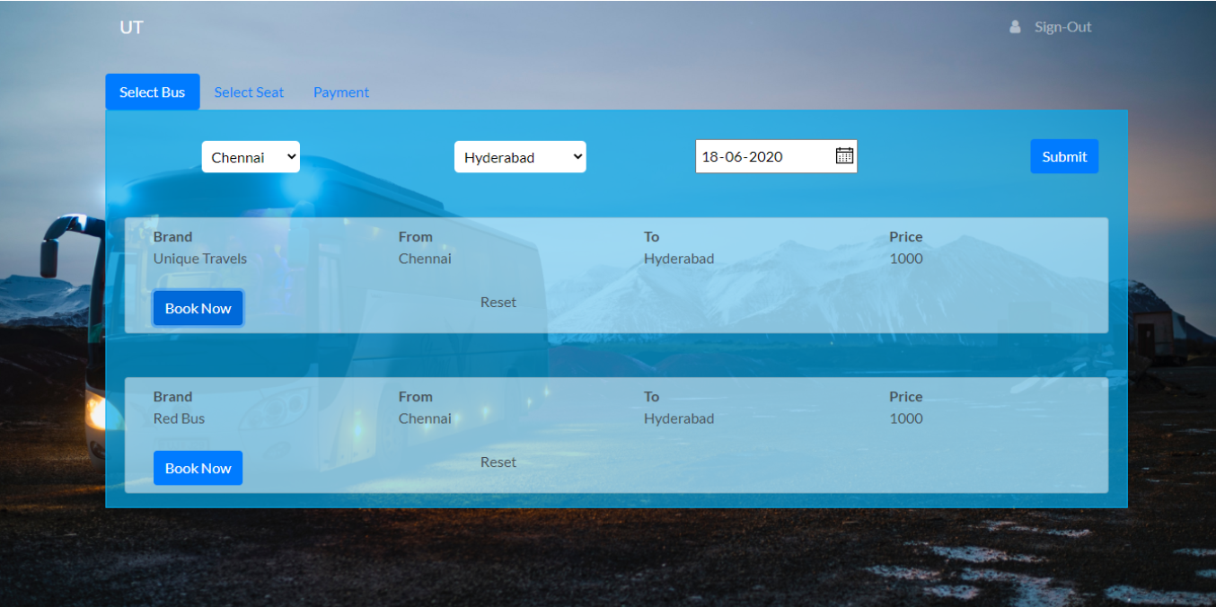

### ****1.3.2Login Page****

The login module ensures user authentication, allowing users to securely access their account and bookings. Key elements include:

* ***Username/Email and Password Fields****:* Basic fields for user credentials.
* ***"Forgot Password" Option****:* Redirects users to a page for password recovery.
* ***Login via Social Media****:* Options to log in with Google, Facebook, etc., for easier access.
* ***Sign-up Link****:* Redirects new users to the registration page.
* ***Security Features****:* Include captcha and multi-factor authentication options to protect against unauthorized access.

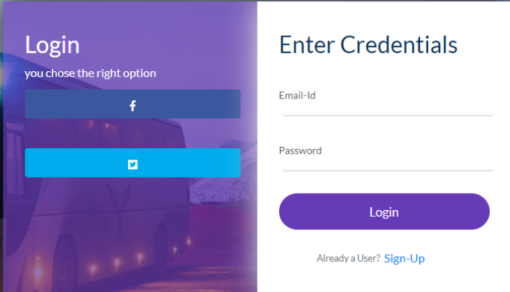

### ****1.3.3Payment Page****

This module allows users to finalize ticket booking by making payments. Necessary details include:

* ***Payment Methods****:* Options for Credit/Debit Card, Net Banking, UPI, and Wallets.
* ***Booking Summary****:* Displays journey details (bus type, timings, boarding point, destination) and fare breakdown, including taxes, discounts, and fees.
* ***Coupon Code Field****:* Option to apply discount codes.
* ***Secure Payment Gateway****:* Integrate a reliable gateway for transaction security.
* ***Payment Confirmation and Receipt****:* After payment, generate a digital receipt that can be saved or printed by the user.
* ***Refund/Cancellation Information****:* Outline policies and provide a link to initiate cancellation and refunds if needed.

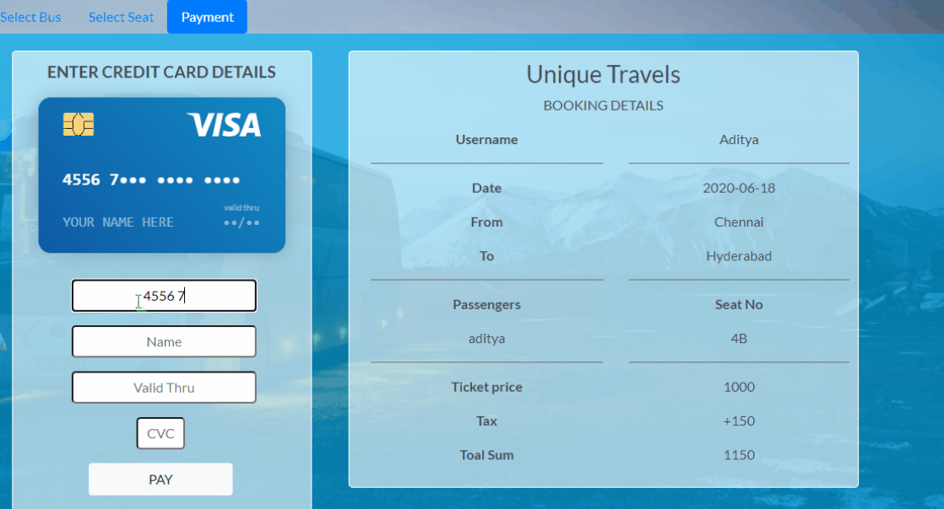

**SURVEY OF TECHNOLOGIES**

****2.1 Software Description****

**Purpose**:The **“*BUS TICKET RESERVATION SYSTEM”*** is developed to streamline the bus booking process by enabling users to book tickets directly through a website, reducing the dependency on physical counters or third-party booking services. It aims to provide a user-friendly and efficient platform for booking bus tickets, calculating costs, and processing quick refunds, enhancing the overall user experience.

**Functionality**:

1. ***Direct Booking****:* Users can book tickets for their desired routes directly on the website, selecting from available buses, seats, and timings.
2. ***Fare Calculation****:* The system calculates the cost of the tickets based on factors like travel distance, seat type, and any applicable discounts.
3. ***Booking Management****:* Users can view, modify, or cancel their bookings, with real-time updates on seat availability.
4. ***Refund Processing****:* Provides an efficient refund mechanism for cancellations, with refunds processed swiftly based on the refund policy.
5. ***User Account Management****:* Allows users to register and manage their accounts, including viewing booking history and stored preferences.

**System Architecture**:

The system follows a client-server model:

* **Frontend**: Developed using HTML, CSS, and JavaScript for a responsive, user-friendly interface.
* ***Backend****:* Powered by [chosen backend technology, e.g., PHP or Node.js] to handle booking requests, calculate fares, and manage business logic.
* ***Database****:* A relational database like MongoDB stores user data, booking records, bus details, and route information.

**Technologies Used**:

* ***Frontend****:* HTML, CSS, JavaScript
* ***Backend****:* [PHP/Node.js]
* ***Database****:* MySQL or similar relational database
* ***Additional Libraries/Frameworks****:* [any specific libraries, e.g., Bootstrap for UI or Express for Node.js]

**User Interface (UI)**:

The system provides an intuitive, easy-to-navigate interface where users can:

* Search for available buses and routes
* Select seats visually from a seat layout
* View trip details, pricing, and apply discounts or promotional codes
* Access account and booking details from a centralized dashboard

**Limitations or Constraints**:

* ***Scalability****:* This is a mini-project designed for a limited number of users and routes; scalability may need to be addressed for larger implementations.
* ***Refund Speed****:* Refund processing depends on external factors like payment gateways, so delays may occur.
* ***Real-Time Updates****:* Seat availability updates are near real-time but could lag slightly due to network or system load

**2.2 LANGUAGES**

### **2.2.1 MongoDB**

MongoDB is a NoSQL database that stores data in a flexible, JSON-like format called BSON. Unlike traditional relational databases, MongoDB doesn’t require a predefined schema, making it very adaptable to changes in data structure. This flexibility is useful for managing complex data, such as user profiles, bus details, booking records, and refund history, which might vary in structure.

*MongoDB is used to:*

* Store user data, bus details, seat availability, and booking information
* Efficiently retrieve booking and availability data
* Support quick data updates (e.g., marking a seat as booked or processing a refund)

### Node.js

Node.js is a server-side JavaScript runtime environment, allowing developers to use JavaScript for backend programming. Known for its speed and efficiency, Node.js is ideal for applications requiring fast, real-time interactions, like a ticket reservation system. With its non-blocking I/O model, Node.js can handle multiple requests concurrently, making it a good fit for handling booking requests, checking seat availability, and processing refunds simultaneously.

*Node.js is used to:*

* Manage and process booking requests
* Calculate ticket prices and refunds
* Serve the API endpoints for actions like search, booking, and cancellations

### How To Connect in This Project

To connect Node.js with MongoDB, you use the **Mongoose** library, which provides a straightforward way to manage MongoDB interactions through schemas and models.

1. **Node.js** interacts with MongoDB using Mongoose to execute database operations.
2. When a user initiates a booking request, **Node.js** communicates with MongoDB to check seat availability, reserve seats, and save booking data.
3. MongoDB returns results (e.g., availability status or booking confirmation), and **Node.js** sends this information back to the user.

**REQUIREMENTS AND ANALYSIS**

### 3.1 Requirement Specification

*For the* ***BUS TICKET RESERVATION SYSTEM****, the requirement specifications are as follows:*

#### Functional Requirements:

1. ***User Registration and Authentication****:* Users must be able to register and log in securely.
2. ***Search and Select Buses****:* Users can search for buses by city, date, and time, and choose seats based on availability.
3. ***Booking and Payment****:* Provides secure payment options, calculates booking costs, and handles real-time ticket booking.
4. ***Cancellation and Refunds****:* Allows users to cancel reservations and initiates fast processing of refunds.
5. ***Admin Management****:* Admin users can manage bus schedules, pricing, seat availability, and generate reports.
6. ***Notifications****:* Sends booking confirmations and cancellation alerts to users via email/SMS.
7. ***Direct Booking on Website****:* Allows users to book directly from the website, enhancing ease of access.

#### Non-Functional Requirements:

1. ***Performance****:* The system should handle multiple bookings simultaneously with minimal latency.
2. ***Scalability****:* Ability to add more cities, buses, and users without a decrease in performance.
3. ***Reliability****:* Ensures data integrity and secure transactions.
4. ***Usability****:* Simple and intuitive interface for users of all ages.
5. ***Security****:* Data encryption for sensitive information (e.g., payment details), secure login, and access control for admin and user levels.

### *3.2 Hardware and Software Requirements*

#### Hardware Requirements:

1. ***Processor****:* Intel i5 or above.
2. ***RAM****:* Minimum 8GB for smooth operation.
3. ***Storage****:* At least 256GB SSD or HDD.
4. ***Internet Connection****:* Required for real-time booking and updates.

#### Software Requirements:

1. ***Operating System****:* Windows 10/11, macOS, or Linux.
2. ***Database****:* MongoDB, as it supports document-oriented storage and flexibility.
3. ***Backend****:* Node.js for handling server-side operations and fast processing.
4. ***Frontend****:* HTML, CSS, JavaScript for user interface development.
5. ***Libraries/Frameworks****:*
   1. ***Express.js****:* For building server-side functionality with Node.js.
   2. **Mongoose**: For MongoDB object modeling.
6. ***Development Environment****:* Visual Studio Code or any IDE compatible with Node.js.
7. ***Version Control****:* Git for managing and tracking project changes.
8. ***Browser****:* Google Chrome, Firefox, or any modern web browser for testing.

**3.3 ARCHITECTURE DIAGRAM**

***The Architecture diagram for Bus Ticket Reservation System*** *using HTML, CSS, JavaScript for frontend; Node.js for backend; and MongoDB for database storage.*

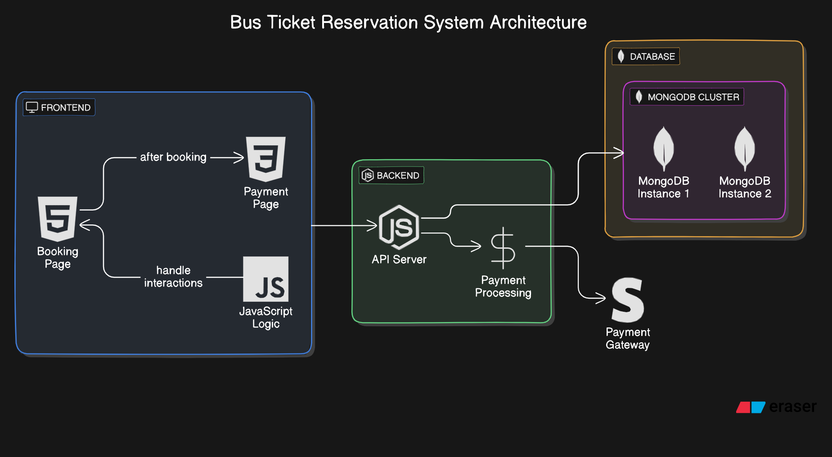

·****User Interface (UI)**:**

***·* ***Pages****:*** The UI includes essential pages like **Bus Search**, **Seat Selection**, **Booking**, and **Payment Confirmation**. This interface is designed with HTML, CSS, and JavaScript to allow users to select and book tickets easily.

***·*  **Frontend**:**

· The frontend is built using **HTML, CSS, and JavaScript**, handling user interactions, validations, and displaying available seats and buses.

* It sends user requests (like search for buses or confirm booking) to the backend and displays responses, such as available seats or booking status.

***·* **Backend**:**

· **Node.js and Express.js** power the backend, which processes requests from the frontend, manages business logic, and communicates with the MongoDB database.

The backend handles core functionalities such as:

* + ***Booking Management****:* Validates seat availability, reserves seats, and updates booking details in MongoDB.
  + ***Payment Processing****:* Manages the payment transaction and updates booking status.
  + ***Authentication****:* Manages user login, registration, and secure access to booking features.

*·* **Database (MongoDB)**:

*·* ***MongoDB*** *stores and retrieves data for the system, including:*

* + **User Data**: Stores user profiles, login credentials, and contact information.
  + **Bus Information**: Maintains details about buses, routes, schedules, and fares.
  + **Booking Records**: Holds each booking’s details, including user, bus, route, and schedule information.
  + **Payment Transactions**: Keeps a record of payment status, amounts, and transaction dates.
* MongoDB’s document-oriented structure enables flexibility in storing complex data such as booking and user details, supporting quick and efficient queries.

**3.4 ER Diagram**

ER diagram for the Bus Ticket Reservation System, visually representing the entities, their attributes, and relationships.



#### *1.* *****Entities******:*

***User****:* Stores information about users.

* + Attributes: UserID (PK), Name, Email, PhoneNumber, Password, Address

***Bus****:* Contains bus information.

* + ***Attributes:*** BusID (PK), BusNumber, Type (e.g., AC, Non-AC), TotalSeats, Operator, Amenities

***Route****:* Defines routes for buses.

* + ***Attributes:*** RouteID (PK), Source, Destination, Distance, *TravelTime*

***Schedule****:* Stores bus schedules for each route.

* + Attributes: ScheduleID (PK), BusID (FK), RouteID (FK), DepartureTime, ArrivalTime, Date

***Ticket****:* Stores details of booked tickets.

* + Attributes: TicketID (PK), ScheduleID (FK), UserID (FK), SeatNumber, BookingStatus (e.g., Confirmed, Canceled), BookingDate

***Payment****:* Manages payment details for bookings.

* + Attributes: PaymentID (PK), TicketID (FK), Amount, PaymentStatus (e.g., Completed, Refunded), PaymentDate, RefundDate

***Admin****:* Handles admin data for system management.

* + Attributes: AdminID (PK), Name, Email, Password

#### *2.* *****Relationships******:*

***User*** *and* ***Ticket****:* A User can book multiple tickets, and each ticket is booked by one User.

* + Relationship: User (1) ↔ (M) Ticket

***Bus*** *and* ***Schedule****:* A Bus can have multiple schedules, but each schedule refers to one Bus.

* + Relationship: Bus (1) ↔ (M) Schedule

***Route*** *and* ***Schedule****:* A Route can have multiple schedules, but each schedule is for one Route.

* + Relationship: Route (1) ↔ (M) Schedule

***Schedule*** *and* ***Ticket****:* A Schedule can have multiple tickets booked, but each ticket refers to one Schedule.

* + *Relationship: Schedule (1) ↔ (M) Ticket*

***Ticket*** *and* ***Payment****:* Each Ticket can have one payment, and each payment is linked to one Ticket.

* + Relationship: Ticket (1) ↔ (1) Payment

***Admin*** *and* ***Bus****:* Admins manage buses, but buses do not directly depend on specific admins for every action.

**3.5 Normalization**

#### ****1NF (First Normal Form)****:

1NF requires that:

* All attributes contain only atomic (indivisible) values.
* Each record is uniquely identifiable.

Let's start by ensuring all tables are in 1NF, with unique primary keys and atomic attributes.

* **User**: Already in 1NF since attributes like Name, Email, PhoneNumber are atomic.
* **Bus**: In 1NF with attributes like BusID, BusNumber, Type.
* **Route**: Attributes Source and Destination are atomic and unique per route.
* **Schedule**: Each schedule entry is atomic, with attributes like ScheduleID, DepartureTime.
* **Ticket**: Attributes like SeatNumber, BookingStatus are atomic.
* **Payment**: Attributes Amount, PaymentStatus are atomic.
* **Admin**: Simple attributes like AdminID, Name.

#### ****2NF (Second Normal Form)****:

2NF requires:

* The table is already in 1NF.
* There are no partial dependencies (no non-key attribute depends on only part of a composite key).

In our case, most entities have a single-attribute primary key, so we mainly check that each attribute depends only on the primary key.

* **User**: No partial dependency. Attributes depend only on UserID.
* **Bus**: No partial dependency. Attributes depend only on BusID.
* **Route**: Attributes depend only on RouteID.
* **Schedule**: Each attribute depends on ScheduleID.
* **Ticket**: Each attribute depends on TicketID.
* **Payment**: Each attribute depends on PaymentID.
* **Admin**: Each attribute depends on AdminID.

At this stage, all tables are in 2NF.

#### ****3NF (Third Normal Form)****:

3NF requires:

* The table is already in 2NF.
* No transitive dependencies (non-key attributes depend only on the primary key, not on other non-key attributes).

We’ll eliminate any transitive dependencies, although most entities already satisfy 3NF.

* **User**, **Bus**, **Route**, **Schedule**, **Ticket**, **Payment**, **Admin**: No transitive dependencies observed, as all non-key attributes depend only on their respective primary keys.

#### ****BCNF (Boyce-Codd Normal Form)****:

BCNF is a stricter version of 3NF, which requires:

* Every determinant must be a candidate key.

In this design, every determinant in each table is indeed a candidate key, meaning the structure already conforms to BCNF.

### ****Fourth Normal Form (4NF)****

4NF applies to scenarios where:

* The table is already in **BCNF**.
* There are **no multi-valued dependencies** (attributes that depend on multiple independent attributes within a table).
* Most entities (e.g., **User**, **Bus**, **Route**, **Schedule**, **Ticket**, **Payment**, **Admin**) are already in 4NF.
* There are no multi-valued dependencies because:
  + Each attribute in each table depends only on the primary key.
  + Relationships like those between User and Ticket, or Schedule and Route, are handled by foreign keys rather than multi-valued dependencies.

Thus, every table in the current design meets 4NF, as each attribute has a single dependency on its primary key.

### ****Fifth Normal Form (5NF)****

5NF, also known as **Project-Join Normal Form (PJNF)**, applies when:

* The table is already in **4NF**.
* It has no **join dependencies** (i.e., no table can be decomposed into smaller tables that can be re-joined without loss of information).

5NF is generally necessary when:

* There are complex many-to-many relationships that cannot be represented accurately in lower normal forms.
* The design requires breaking down data into more granular entities, often in complex relational models.

**PROGRAM CODE**

**APP.JS**

var express = require('express');

var path = require('path');

var cookieParser = require('cookie-parser');

var logger = require('morgan');

var mongoose = require('mongoose');

var passport = require('passport');

const cors = require('cors')

var app = express();

// Login and Register

require('./auth/auth');

const login = require('./routes/login')

const loggedInPage = require('./routes/loggedInUser');

// ----------------------------------------------------

const bookingRoute = require('./routes/routeSelection')

var registerRouter = require('./routes/register');

//--------------------------------------------------------

//DB Config

const DB_URL = require('./config/keys').MongoURI;

//connect to mongo

//---------------------------------------------

mongoose.connect(DB_URL, {

useNewUrlParser: true,

useUnifiedTopology: true

})

.then(() => {

console.log("Connected to MongoDB")

})

.catch(err => {

throw err

})

//---------------------------------------------

app.use(logger('dev'));

app.use(express.json());

app.use(express.urlencoded({ extended: false }));

app.use(cookieParser());

app.use(express.static(path.join(__dirname, 'public')));

app.use(cors())

app.use('/', login);

app.use('/booking', bookingRoute);

app.use('/register', registerRouter); // To register page

app.use('/user', passport.authenticate('jwt', { session: false }), loggedInPage); //To Secure Route

module.exports = app;

**PACKAGE.JSON**

{

"name": "backend",

"version": "0.0.0",

"private": true,

"scripts": {

"start": "node ./bin/www",

"devStart": "nodemon ./bin/www"

},

"dependencies": {

"bcrypt": "^4.0.1",

"bcryptjs": "^2.4.3",

"body-parser": "^1.19.0",

"cookie-parser": "~1.4.4",

"cors": "^2.8.5",

"debug": "~2.6.9",

"express": "~4.16.1",

"express-session": "^1.17.1",

"jsonwebtoken": "^8.5.1",

"moment": "^2.26.0",

"mongoose": "^5.9.16",

"morgan": "~1.9.1",

"passport": "^0.4.1",

"passport-jwt": "^4.0.0",

"passport-local": "^1.0.0"

}

}

**Index.html**

<!DOCTYPE html>

<html lang="en">

<head>

<meta charset="utf-8" />

<link href="https://maxcdn.bootstrapcdn.com/font-awesome/4.7.0/css/font-

awesome.min.css" rel="stylesheet" integrity="sha384-

wvfXpqpZZVQGK6TAh5PVlGOfQNHSoD2xbE+QkPxCAFlNEevoEH3Sl0sibVcOQVnN" crossorigin="anonymous">

<link href="https://fonts.googleapis.com/css2?family=Lobster&display=swap" rel="stylesheet">

<link rel="icon" href="%PUBLIC_URL%/favicon.ico" />

<meta name="viewport" content="width=device-width, initial-scale=1" />

<meta name="theme-color" content="#000000" />

<meta name="description" content="Web site created using create-react-app" />

<link rel="apple-touch-icon" href="%PUBLIC_URL%/logo192.png" />

<!--

manifest.json provides metadata used when your web app is installed on a

user's mobile device or desktop. See https://developers.google.com/web/fundamentals/web-app-manifest/

-->

<link rel="manifest" href="%PUBLIC_URL%/manifest.json" />

<!--

Notice the use of %PUBLIC_URL% in the tags above.

It will be replaced with the URL of the `public` folder during the build.

Only files inside the `public` folder can be referenced from the HTML.

Unlike "/favicon.ico" or "favicon.ico", "%PUBLIC_URL%/favicon.ico" will

work correctly both with client-side routing and a non-root public URL.

Learn how to configure a non-root public URL by running `npm run build`.

-->

<title>Unique Travels</title>

</head>

<body>

<noscript>You need to enable JavaScript to run this app.</noscript>

<div id="root"></div>

<!--

This HTML file is a template.

If you open it directly in the browser, you will see an empty page.

You can add webfonts, meta tags, or analytics to this file.

The build step will place the bundled scripts into the <body> tag.

To begin the development, run `npm start` or `yarn start`.

To create a production bundle, use `npm run build` or `yarn build`.

-->

<script src="https://code.jquery.com/jquery-3.2.1.slim.min.js"

integrity="sha384-KJ3o2DKtIkvYIK3UENzmM7KCkRr/rE9/Qpg6aAZGJwFDMVNA/GpGFF93hXpG5KkN"

crossorigin="anonymous"></script>

<script src="https://cdnjs.cloudflare.com/ajax/libs/popper.js/1.12.9/umd/popper.min.js"

integrity="sha384-ApNbgh9B+Y1QKtv3Rn7W3mgPxhU9K/ScQsAP7hUibX39j7fakFPskvXusvfa0b4Q"

crossorigin="anonymous"></script>

<script src="https://maxcdn.bootstrapcdn.com/bootstrap/4.0.0/js/bootstrap.min.js"

integrity="sha384-JZR6Spejh4U02d8jOt6vLEHfe/JQGiRRSQQxSfFWpi1MquVdAyjUar5+76PVCmYl"

crossorigin="anonymous"></script>

</body>

</html>

***5. RESULTS AND DISCUSSION***

### *5.1 RESULTS*

### ****Efficient Booking Process****

1.Users can directly book bus tickets through the application, bypassing intermediaries. The system allows for real-time seat selection and reservation, improving user experience.

2.The system handles high volumes of data and multiple simultaneous requests effectively, showcasing its reliability.

**Fast Payment Processing and Refunds**

**1.**The integration of a streamlined payment module enables users to complete transactions quickly. The system supports instant confirmation of payments, providing a seamless booking experience.

2.Refund processes are automated for canceled bookings, allowing for prompt returns, which enhances customer satisfaction and trust.

**Comprehensive Data Management**

1.The system successfully organizes complex data structures related to users, buses, routes, schedules, tickets, and payments in a well-normalized MongoDB database.

2.This structured data management ensures that data redundancy is minimized, and queries are optimized for quick data retrieval.

**User and Admin Modules**

1.Users can access their booking history, track reservations, and initiate cancellations as needed.

2.Admins can manage bus schedules, add or modify route information, and oversee bookings and cancellations, ensuring smooth operation and service availability.

**Scalability and Flexibility**

1.With the use of Node.js and MongoDB, the system is scalable and can handle an expanding number of users and transactions. The system’s design allows for easy integration of additional features in the future, such as analytics or integration with other transportation systems.

### ****Discussions****

**System Efficiency and User Convenience**

1.By eliminating intermediaries, the system directly benefits both bus operators and passengers, offering cost savings and more control over booking processes.

2.The system’s user-friendly interface improves accessibility, catering to a broader audience, especially in rural areas with limited access to traditional booking offices.

**Data Consistency and Integrity**

1.With thorough normalization, the system ensures data integrity across all modules. Each booking transaction is accurately recorded, allowing for seamless interactions between modules.

2.MongoDB’s flexibility with unstructured data could be leveraged for future functionalities, like handling route variations due to road conditions or seasonal demand changes.

**Challenges Faced**

**1.Handling Concurrency**: Managing simultaneous bookings for the same seat or schedule was a challenge. Implementing locking mechanisms or queuing processes ensures seat availability accuracy.

**2.Payment Integration**: Ensuring secure and smooth integration with third-party payment gateways required careful attention to security protocols.

3.**Refund System**: Automating refunds was challenging, as it involved both user notifications and adherence to different bank processing times.

**Potential Improvements**

1. **Enhanced Reporting and Analytics**: Future versions could include detailed analytics for operators, offering insights on popular routes, peak booking times, and user demographics.

**2.Improved Customer Support**: Adding a support module with chatbot or live chat capabilities can help users with inquiries and booking issues in real-time.

**3.Mobile Application**: Developing a mobile app version of the system could increase accessibility, especially for users in regions with limited desktop access.

**6.CONCLUSION**

The **Bus Ticket Reservation System** effectively meets its objectives by providing a streamlined platform for direct ticket bookings, removing intermediaries and lowering costs. Designed with MongoDB and Node.js, the system handles high transaction volumes with features like real-time seat selection, automated payments, and quick refunds, ensuring a smooth user experience and operational efficiency for bus operators. Data is organized in a well-normalized structure, reducing redundancy and enabling fast retrieval, while concurrency mechanisms ensure accurate seat availability. The system’s modular design supports future enhancements, such as analytics and a mobile app, making it a scalable and adaptable solution that enhances accessibility and reliability for users in the bus travel industry.

**7.REFERENCES**

1. **Database Management and Design**

* · Elmasri, R., & Navathe, S. B. (2015). Fundamentals of Database Systems. Pearson Education.
  + This book provides foundational knowledge on database design, including normalization principles applied in the system.
* Chodorow, K. (2013). MongoDB: The Definitive Guide: Powerful and Scalable Data Storage. O'Reilly Media.
  + A practical guide to MongoDB, useful for understanding schema design, indexing, and optimization within NoSQL databases.

2. **Backend Development and System Architecture**

* · Cantelon, M., Harter, M., Holowaychuk, T., & Rajlich, N. (2014). Node.js in Action. Manning Publications.
  + Covers key concepts for building efficient and scalable server-side applications with Node.js, relevant to implementing the backend.
* Martin, R. C. (2008). Clean Code: A Handbook of Agile Software Craftsmanship. Prentice Hall.
  + A great resource for writing maintainable and efficient code, especially when managing complex server-side functionality in Node.js.

3. **Web Development and Security**

* · Fowler, M. (2002). Patterns of Enterprise Application Architecture. Addison-Wesley.
  + Discusses design patterns and architecture models that can enhance system scalability and maintainability.
* Stuttard, D., & Pinto, M. (2011). The Web Application Hacker's Handbook: Finding and Exploiting Security Flaws. Wiley.
  + A valuable resource for implementing secure payment systems and protecting user data in web applications.

4. **E-Commerce and Online Ticketing Systems**

* · Laudon, K. C., & Traver, C. G. (2020). E-Commerce 2020: Business, Technology, and Society. Pearson Education.
  + Provides insights into e-commerce best practices, including secure payment integration and customer experience optimization, relevant to online ticketing.
* Singh, A. (2019). Advanced Digital Ticketing Solutions and Future Innovations. Journal of Transport and Mobility Solutions, 5(3), 122-134.
  + Discusses current trends and technology in digital ticketing systems, which may inspire additional features for the reservation system.

**5.User Experience and System Usability**

* · Norman, D. A. (2013). The Design of Everyday Things. Basic Books.
  + Offers principles of intuitive design that can be applied to improve the user interface and overall usability of the reservation system.
* Krug, S. (2014). Don’t Make Me Think, Revisited: A Common Sense Approach to Web Usability. New Riders.
  + A practical guide to designing user-friendly interfaces, ensuring the booking system is accessible to a broad audience.